Recovery services vault:

A Recovery Services vault is a storage entity in Azure that houses data. The data is typically copies of data, or configuration information for virtual machines (VMs), workloads, servers, or workstations. You can use Recovery Services vaults to hold backup data for various Azure services such as IaaS VMs (Linux or Windows) and SQL Server in Azure VMs. Recovery Services vaults support System Center DPM, Windows Server, Azure Backup Server, and more. Recovery Services vaults make it easy to organize your backup data, while minimizing management overhead.

MARS- Microsoft Azure Recovery Services Agent:

Azure Backup uses the Microsoft Azure Recovery Services (MARS) agent to back up and recover files, folders, and the volume or system state from an on-premises computer to Azure.

Backup scenarios
The MARS agent supports the following backup scenarios:
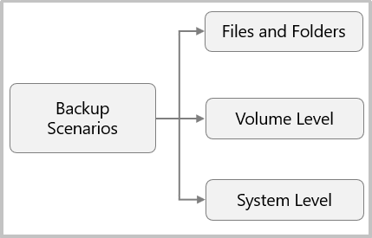
Scenarios | Description
Files and Folders | Selectively protect Windows files and folders.
Volume Level | Protect an entire Windows volume of your machine.
System Level | Protect an entire Windows system state.
The MARS agent supports the following recovery scenarios:
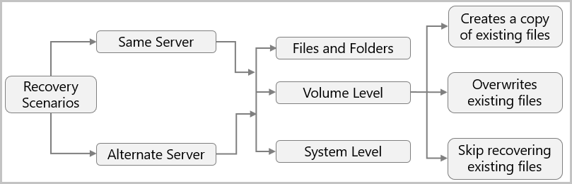

Server | Recovery scenario | Description
Same Server |  | The server on which the backup was originally created.
 | Files and Folders | Choose the individual files and folders that you want to restore.
 | Volume Level | Choose the volume and recovery point that you want to restore, and then restore it to the same location or an alternate location on the same machine. Create a copy of existing files, overwrite existing files, or skip recovering existing files.
 | System Level | Choose the system state and recovery point to restore to the same machine at a specified location.
Alternate Server |  | A server other than the server where the backup was taken.
 | Files and Folders | Choose the individual files and folders whose recovery point you want to restore to a target machine.
 | Volume Level | Choose the volume and recovery point that you want to restore to another location. Create a copy of existing files, overwrite existing files, or skip recovering existing files.
 | System Level | Choose the system state and recovery point to restore as a System State file to an alternate machine.

The following diagram shows the backup flow:
